Banana Chocolate Chip Mini's
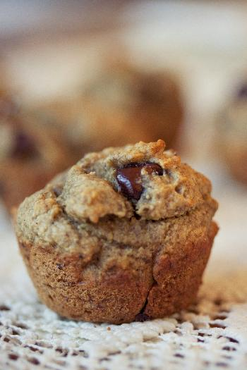
Gluten Free, no-refined sugar and super delicious!
Yield: 30–32 mini muffins
2 cups GF oat flour or spelt flour
1½ teaspoons baking soda
½ teaspoon salt
¼ teaspoon cinnamon
¼ teaspoon cardamom (optional)
½ cup coconut oil, melted, or grapeseed oil
½ cup Grade B maple syrup or 1 cup date paste (see below for recipe)
2 flaxseed eggs (whir 2 tablespoons ground flax in a blender with 6 tablespoons of water until frothy, let sit 5 minutes to gel up)
3 ripe bananas, mashed
2 teaspoons vanilla
½ cup vegan or grain-sweetened chocolate chips
Preheat the oven to 350 degrees F. Line mini muffin tins with papers or grease with coconut oil.
In a large bowl, stir together the flour, baking soda, salt, cinnamon, and cardamom (if using). In a smaller bowl, whisk together the coconut oil and agave nectar until well combined. Add the flaxseed eggs, banana, and vanilla, and stir together until well incorporated.
Pour the banana mixture over the dry mix and stir with a wooden spoon to combine well. Stir in the chocolate chips. Fill mini muffin tins about two-thirds full. Bake for 7 to 10 minutes. Remove from the oven and place on a wire rack to cool. These can keep up to five days in an airtight container.
Date Paste
Pour 2/3 cup of hot water over 1 cup pitted dates and then soak for about 20 minutes. Throw all of the ingredients into a blender and process until a smooth, thick paste is formed.

