**TRAFFIC ADVISORY – SOUTH VALLEY**
MULHOLLAND DRIVE, BEVERLY GLEN BOULEVARD TO NICADA DRIVE
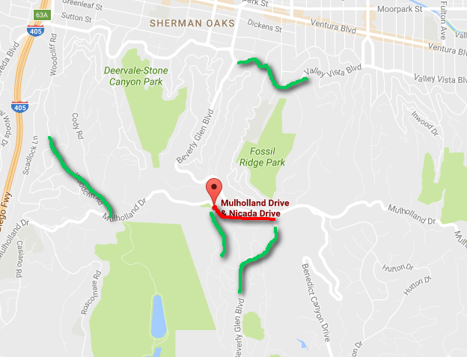
Image from Google Maps.

WHAT: City of Los Angeles, Bureau of Street Services will resurface the street on Mulholland Drive, from Beverly Glen Boulevard to Nicada Drive

There will be full closure of the street with the above limits during scheduled working hours on Saturday, May 27, 2017.

The public is advised to use Nicada Dr., Beverly Glen Bl., Woodcliff Rd., Valley Vista Bl. or an alternate route.

WHEN: Saturday, May 27, 2017, 6:00 A.M. to 6:00 P.M.

WHERE: Mulholland Dr., Beverly Glen Bl. to Nicada Dr. – May 27th

CONTACT: JOHN SAPONE
BUREAU OF STREET SERVICES
(818) 756-8651
# # #

