**TRAFFIC ADVISORY – WEST LOS ANGELES**
SUNSET BOULEVARD, FROM WESTWOOD PLAZA TO VETERAN AVENUE
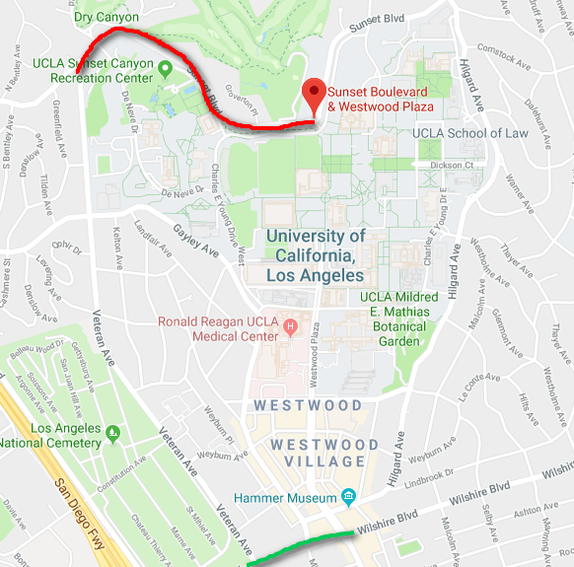
Image from Google Maps.

WHAT: City of Los Angeles, Bureau of Street Services will cold plane and resurface the street on Sunset Boulevard, from Westwood Plaza to Veteran Avenue

Traffic will be restricted to one lane in each direction during scheduled
working hours.

The public is advised to use Wilshire Bl. or other alternate routes.

WHEN: Saturday, April 7, 2018 and Sunday, April 8, 2018, 6:00 A.M. to 6:00 P.M.

WHERE: Sunset Boulevard, from Westwood Plaza to Veteran Avenue

CONTACT: JOHN SAPONE
BUREAU OF STREET SERVICES
(818) 756-8651

